

High Fashion with an Edge:

A campaign to reposition Dr. Martens as high fashion footwear

By
Samantha Dunn, Eric Langberg and Matthew Schreiber

Objectives
The goal of this advertising campaign is to completely overhaul the brand image for Dr. Martens footwear. The campaign aims to reposition Dr. Martens as a trendy, moderately-priced footwear that can be paired well with high-fashion outfits. Dr. Martens was originally known as a middle-class workboot for people who were on their feet all day, such as postmen and factory workers, and has since become associated with the punk subculture due to a rise in popularity among that group in the 1980’s. This ad campaign will play off of the history of the brand, remaining conscious of the company’s origin and position as a subculture staple, while bringing the brand forward into the 21st century and helping it to fulfill its true potential as a high-fashion shoe.

The campaign will include five major areas of advertising: outdoor, television, online, and magazine/print ads in addition to an increased social media presence for the brand.

Target Audience
This advertising campaign will be targeted at a younger, fashion-savvy audience. Our primary audience is middle- to upper-class men and women aged 18 to 35. We’ll reach this audience through strategically placed magazine, television, outdoor, and online advertisements.

Background Information
Dr. Martens shoes were developed by Klaus Märtens, a doctor in the German army during World War II. The cushioned, trademark “Air Wair” sole was intended to be as comfortable as possible which is why the brand initially gained popularity with people who worked on their feet for long periods of time: postmen, factory workers, policemen, etc. In the 1980’s, the shoes were adopted as a fashion staple of the skinhead and punk subculture in England and eventually gained popularity in cities throughout the United States (www.drmartens.com).

Currently, Dr. Martens is running an advertising campaign called “First And Forever.” This campaign, featuring model/actress Agyness Deyn and model Ash Stymest as the faces of the brand, aims to create a nostalgic feeling in the viewer. The campaign features print, outdoor, and television advertisements showing Deyn and Stymest enjoying a night on the town. The campaign is mostly centered around the United Kingdom. Our advertising campaign, however, will be a global one (www.drmartens.com).

Dr. Martens footwear costs anywhere from $50 to $300, depending on the product. This puts Dr. Martens in the same price bracket as competitors such as Hunter Boots, Steve Madden, and UGG Australia (www.drmartens.com, http://www.uggaustralia.com, www.hunter-boot.com).

Through a series of print, online, television, and outdoor advertisements, we plan to bring Dr. Martens into the 21st century with a campaign that shows off the high-fashion potential of the line. By pairing the shoes, specifically the iconic yellow stitching, with fashionable clothing and situations, we hope to create an association in the mind of the viewer that links Dr. Martens and high fashion.

Media Strategy

With our new Dr. Martens campaign, we would like to make use of all possible advertising media offered by the digital age. In recent years, advertising has made a shift from primarily print to a more concentrated online presence, specifically making use of social media. While our campaign will still have outdoor, print, and television ads, we will make use of online and social media advertisements as well to gain a competitive advantage over our competition.

How to Reach Audience
Outdoor, television, online, and print advertisements are the ideal mediums to attract the target audience.

Outdoor advertisements that feature well-dressed young adults wearing the boots will be featured on billboards across major metropolitan areas of the United States, especially those that feature milder climates at some point in the year since the boots are ideal for cool weather. Western European cities that are highly conscious of modern trends will feature similar advertisements on billboards in major cities. The billboards will feature eveningwear to show the versatility of Dr. Martens boots and how they can be worn at any time — not just during the day, but also dressed up at night.

Television commercials developed for this advertising campaign will feature the lesbian, gay, bisexual and transgender community, long recognized for its fashion sense and presence at the forefront of new trends. These advertisements will recall Dr. Martens’ history as a subculture brand, while remaining cognizant of 21st century social trends and minorities.

Online advertisements will match the colors and themes portrayed throughout the rest of the advertising campaign. These advertisements will be placed on websites where our target audience is most likely to frequent, such as the websites for GQ, Perez Hilton, Facebook, Cosmopolitan, VMagazine, LookBook.nu, W, Vogue, etc. These online advertisements (in the form of pop-ups and banners) will be used worldwide. The ads will suggest that the viewer click to quickly access www.drmartens.com.

In addition, an online contest to be the face of Dr. Martens will take place on Facebook and Lookbook.nu. Because many fashion-forward, artistic young individuals are already using Dr. Martens as a high-fashion accessory, and are already uploading pictures of themselves using the product to these social media sites, it makes sense to tap into this market. Participants will be asked to upload pictures of themselves wearing Dr. Martens in interesting ways. The winning looks will be featured in a print advertising campaign. Aside from a future advertising campaign using the winners as models, this brand reinvention is practically costless and will encourage audience participation in the brand. Hopefully, it will bring free publicity to the brand through social media.

The advertisements that will eventually be created using the social media competition’s winners will be an important part of future advertising campaigns. The first strategy that will be utilized with the print advertisements will be to place them in high-fashion magazines such as W Magazine and Vogue. The second part of the strategy will be to make sure that they are featured prominently in many cover stories and editorials in order to raise brand awareness among the extremely fashion conscious.

When to Reach the Audience
To coincide with the general trends in fashion, the advertising campaign will be launched in time for the Spring/Summer 2012 collection from Dr. Martens. The social media competition would be launched now.

Why Use These Media Formats
We chose these media outlets for several reasons. The outdoor ads will be placed in cities known for their diverse populations and sense of style that will help Dr. Martens to gain attention in areas with high traffic. Television commercials will help us to reach an audience that is watching networks with some kind of fashion association and an appeal to the LGBT community (i.e. Bravo, Style, etc.). Online ads will help us to reach an audience that is following fashion on the Internet and with just a few clicks this audience will be able to view the ad and go straight to purchasing the boots. Social media is the newest and one of the most effective ways to advertise to young people today. People look to Facebook and Lookbook.nu for the newest looks in fashion and we feel these outlets will be highly recognized by the audience we are aiming for. Finally, the print advertisements will reach a crowd that has been dedicated for many years. Print is the ultimate source for fashion, especially in publications such as W Magazine and Vogue that are highly regarded in their field and trusted by high-end labels to advertise in.

Relationship to the Six Consumer Responses
This advertising campaign aims to appeal to five out of the six consumer responses including cognition, perception, affective/emotion, persuasion behavior, and association.

  - Cognition:
We feel as though our advertisements are easy to understand and are clear on how to wear the product and the type of person that we envision our product to be worn by. The viewer should see the ad and know exactly what the campaign is attempting to do (Wells, Moriarty, and Burnett 10-19).
  - Perception:
Perception leads to cognition. Our advertisements will be in places that allow the consumer to see them without having to go out of their way. The placement of the ads will make it easy for perception to occur, and most importantly, for purchases to follow (Wells, Moriarty, and Burnett 10-19).

  - Affective/Emotion:
We believe our advertisements will have an emotional aspect to them because there will be an element of surprise due to the drastic product repositioning. Those familiar with Dr. Martens are not used to seeing the boots styled in such a way. At first, many may be shocked to see the change, but we want people to be aware that these are the same boots, we are just letting our audience know that they don’t have to be confined to the one particular style they have associated with Dr. Martens for years (i.e. associated with punk clothing styles) (Wells, Moriarty, and Burnett 10-19).
  - Persuasion Behavior:
We think that our ads look professional and sleek enough to persuade our viewers to go and purchase the boots. The beauty of online advertising is that the viewer can click and order in just a few minutes after initially seeing the advertisement. Furthermore, social media offers two-way communication so that potential customers’ questions can be answered by Dr. Martens employees that are working the Facebook page (Lamb, Hair, and McDaniel 229) (Wells, Moriarty, and Burnett 10-19).
  - Association:
Our target audience frequently reads high-end fashion magazines and is also digitally connected to social media sites. They want the newest trends as soon as they’re available. We think that by marketing our new campaign via high-end magazines, billboards, online advertisements, and social media pages we will be able to get in touch with these customers. They already identify with the advertisements they see in magazines such as Vogue and W Magazine so we think they will see our ads and view them in the same light (Wells, Moriarty, and Burnett 10-19).

Advertising Message Theme

Competition:
Key competitors would include designers that offer similarly priced trendy boots, such as
UGG Australia, Steve Madden, and Hunter Boots.

Message to the Target Audience:
Modern day Dr. Martens boots not only have the utility and durability of their iconic industrial forefathers, but they can also be used to accentuate style, flair and uniqueness; this truly makes them a must-have for any fashion-conscious young man or woman. Dr. Martens are a high fashion, luxury product and are no longer just a utility boot for the working class.

Support
Each member of our group has had an experience with Dr. Martens, but these experiences are not what we envision for the brand. There is still a large “punk” scene in this country and around the world comprised of young people. The punk crowd has worn Dr. Martens ever since the 1980’s, and while there is nothing wrong with the way that they wear them, we think that the boots have the potential to reach a new, more mature crowd, freed of the “punk” association.

There is a punk venue in Pittsburgh, Pennsylvania in the Lawrenceville neighborhood known for its lack of upkeep and a crowd with classic grunge-punk style. At a concert back in the fall of 2010, Samantha noticed a girl wearing the classic Dr. Martens 1919 boot, but the rest of her outfit was highly uncharacteristic for this venue. Her black 1919 boots were paired perfectly with a black open-backed sequin shift dress, her hair in a topknot and lips in the brightest magenta. This partygoer was wearing Dr. Martens with an outfit one would normally think to wear with heels. Right then and there, the idea that Dr. Martens could be worn as high fashion become a viable one. The juxtaposition of luxury fashion pieces with a boot known for its durability seemed like the perfect fit.

Constraints
In executing and implementing this brand-overhaul advertising campaign, we faced several difficulties and constraints.

First, our television advertisements will features gay couples. The ads will be socially forward thinking, but there’s a chance that the advertisement could cause backlash from conservative viewers. Either way, the ad will generate press, which would be good for the company since it currently receives minimal media coverage.

A second constraint in implementing the advertising campaign would be cost. The campaign will feature advertisements in a number of formats and try to reach customers in as many areas as possible. Needless to say, designing and running each advertisement will be costly. In addition, the online campaign will involve an increased social media presence for the brand, which means that there needs to be increased staff devoted to managing the brand online.

As far as constraints for creating this project itself, the biggest one that we faced was time. We all had very busy schedules, so it was difficult to coordinate times when we could all meet together to work on the project.

Another constraint for the project will be our limited graphic design skills. Our advertising campaign will feature a number of visual advertisements, from our online ad, to our outdoor ad, to our print ad and the social media contest, so we will need to work together to overcome the lack of design experience.

Evaluation

The advertisements themselves have a consistent message that is right in line with our target market. The goal of the ads is to help the target market to see that Dr. Martens footwear can be paired with high fashion clothing, adding a bit of edginess that’s consistent with the heritage of the brand itself. Since we are targeting men and women aged 18-35 who are upper-middle class and fashion-savvy, our audience is already paying close attention to the places that we’ve put the ads themselves (high-fashion publications, fashion forward television shows, etc.). Since the ads offer something new, something different, our audience is likely to copy the trend that they see in the ads.

Our project’s main objective was to revolutionize the brand image of Dr. Martens footwear, offering the shoes as a potential high-fashion accessory. We felt that we hit this objective fairly well. We gathered inspiration from Hunter’s autumn/winter 2011-2012 advertising campaign for their iconic rain boots to brainstorm possible ways to modernize a classic wardrobe staple and to make it truly high-fashion. What we found was that their advertisements are straightforward and display the product exactly how the target audience would wear it. For our project with Dr. Martens, we did something similar. Our advertisements are simple, focus on the shoes, and offer our audience potential ways to use the product. While there were some shortcomings in the execution itself - to be discussed below - we felt that we met our objective as a whole quite well (www.hunter-boot.com).

In terms of execution, we felt that the outfits that the models were wearing in the ads were quite representative of what we’d imagine our target audience to identify with. By pairing the boots with these trendy, yet refined outfits, we are offering the audience an opportunity to see what the entire ensemble can look like when properly styled. We felt that we successfully placed our ads where young, upper-middle class people would be looking - television, social media, fashion magazines, etc.

We think that the quality of our execution could have been higher through the use of professional models, photography and graphic design. We are admittedly quite elementary in our photoshopping capabilities that created a shortcoming in the campaign itself.

Samantha was responsible for brainstorming advertisement ideas, the development of the creative strategy and coming up with the best possible outlets to place the ads. Matthew worked to create the print, online and outdoor advertisements utilizing Adobe Photoshop. He also worked on the creative strategy itself and revisions. Eric was responsible for the television advertisement script as well as developing and designing the social media-focused online campaign. In addition, with his group members, he worked on writing the background information, audience profile, and creative strategy.

We found that working with partners was a good way to collaborate on creative ideas and to brainstorm as many advertising concepts as possible. Our personal backgrounds in terms of fashion varied widely which gave us the ability to feed off of each other’s unique ideas. With differing personal tastes, we were able to come up with a creative strategy that encompassed all of them. One of the biggest issues that we ran into was coordinating our schedules to meet up and complete the campaign. As a whole, though, we felt that working with several people helped to strengthen and diversify our final product.

Works Cited - SOURCES

"Autumn/Winter 2011-2012 Campaign." www.usa.hunter-boot.com. Web. 29 Nov. 2011.

Dr. Martens Airwair- Shoes, Boots and Sandals -HOME. Web. 17 Oct. 2011.
<http://www.drmartens.com/>.

Lamb, Charles W., Joseph F. Hair, and Carl D. McDaniel. MKTG5: Student Edition. Mason, OH:
South-Western Cengage Learning, 2012. Print.

Lockwood, Lisa. "Dr. Martens to Launch 'First and Forever' Campaign." WWD - Women's Wear
Daily. 9 Aug. 2011. Web. 01 Dec. 2011.
<http://www.wwd.com/media-news/advertising/first-things-first-5046120>.

UGG® Australia | Boots, Shoes, Slippers & Apparel. Web. 02 Dec. 2011.
<http://www.uggaustralia.com>.

Wells, William. Sandra Moriarty and John Burnett. “How Advertising Works.” Advertising Principles and Practice. 7th Edition. Upper Saddin River, New Jersey: Pearson Prentice Hall, 2006.

Works Cited - IMAGES

A, Mohcine. The Sucker. 2011. Photograph. Casablanca. Lookbook.nu. 5 Sept. 2011. Web. 28
Nov. 2011. <http://lookbook.nu/look/2389101-THE-SUCKER>.

J, Blake. Cause He Made You Perfect, Babe. 2011. Photograph. Los Angeles. Lookbook.nu. 20
Feb. 2011. Web. 28 Nov. 2011.
<http://lookbook.nu/look/1613583-Cause-he-made-you-perfect-babe>.

J, Victoire. Bohemian like You. 2010. Photograph. Vienna. Lookbook.nu. 7 Aug. 2011. Web. 28
Nov. 2011. <http://lookbook.nu/look/951793-bohemian-like-you>.

L, Philipp. Dead Road Seven Is a Bitch. 2010. Photograph. Germany. Lookbook.nu. 28 Jan. 2011.
Web. 28 Nov. 2011. <http://lookbook.nu/look/951793-bohemian-like-you>.

M, Annia. +*+* MARIE ANTOINETTE. 2011. Photograph. Halifax. Lookbook.nu. 2 Feb. 2011.
Web. 28 Nov. 2011. <http://lookbook.nu/look/1558072-MARIE-ANTOINETTE>.

Online Ad: Social Media Contest — “Show Us Your Edge” Campaign

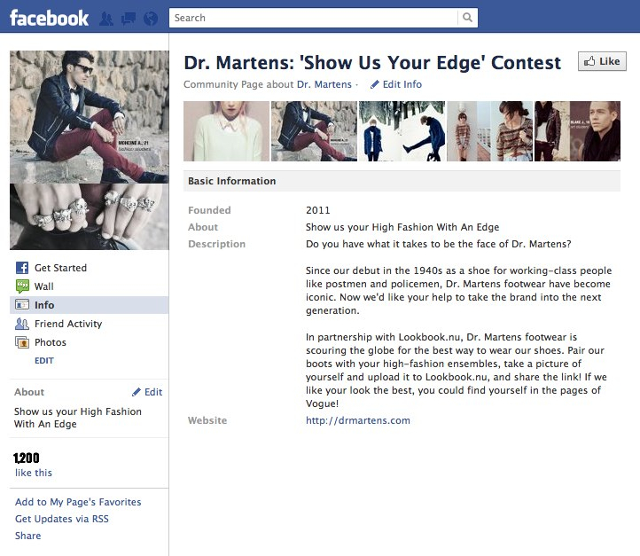

Online Ad: Social Media Contest — “Show Us Your Edge” Campaign (continued)

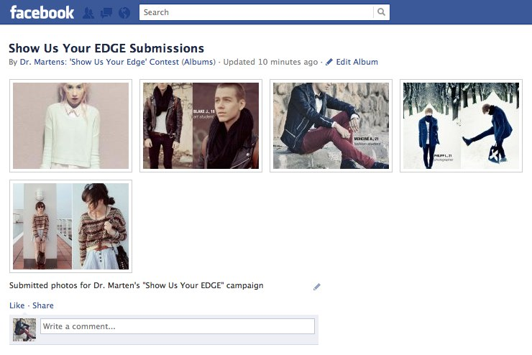

Online Ad: Social Media Contest — “Show Us Your Edge” Campaign (continued)

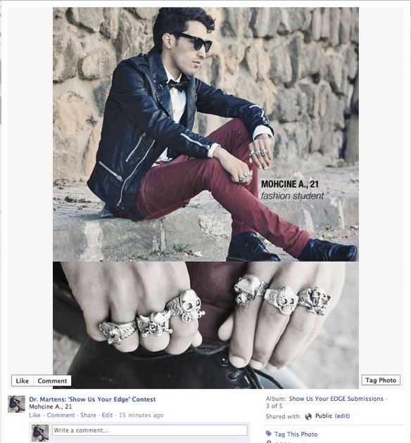

Online Ad: Social Media Contest — “Show Us Your Edge” Campaign (continued)

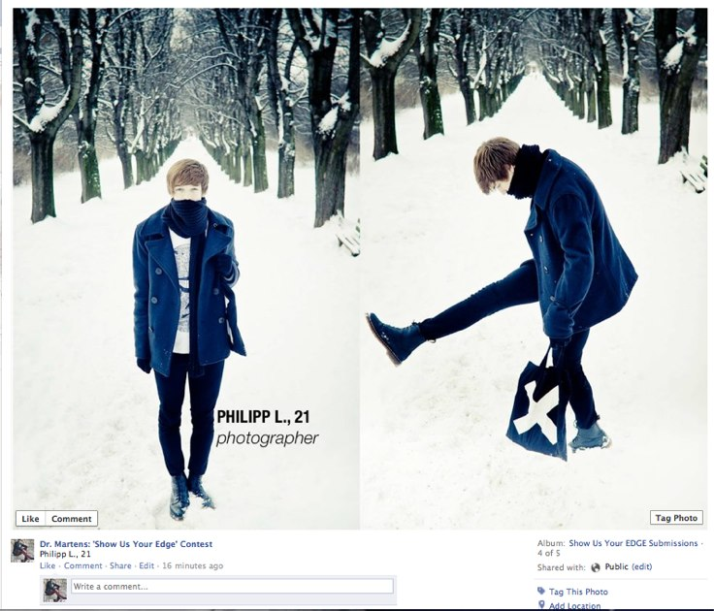

Online Ad: “High Fashion with an Edge” - Pop-up Advertisement

Television Ad: Dr. Martens - “Across a Crowded Club” - 30-second spot

1 LOW TRACKING SHOT OF DANCING SFX: Loud dance FEET (MALE SHOES) IN A CROWDED CLUB. music, in time with
LIGHTS PULSING, FLASHING. the pulsing lights

2 AFTER TEN SECONDS OF TRACKING,

CAMERA COMES TO REST ON A PAIR OF
DANCING DR. MARTENS. WE CAN SEE THE
ICONIC YELLOW STITCHING ON THE SOLE.

THE LIGHTS AND HEIGHTENED CONTRAST

MAKES THE YELLOW STITCHING BRIGHT.

3 SUDDENLY, A SMARTPHONE SLIDES ACROSS SFX: Faint noise of
THE FLOOR RIGHT -> LEFT TOWARD THE DR. MARTENS. sliding phone.

THE SHOES STOP DANCING AND LIGHTLY STEP ON THE

PHONE, STOPPING IT FROM SLIDING.

4 CAMERA PULLS BACK SLIGHTLY. FROM THE RIGHT

ENTERS A HANDSOME, WELL-DRESSED YOUNG MAN

ON HIS HANDS AND KNEES, CRAWLING TOWARD THE
PHONE. HE SEES THE DR. MARTENS AND PAUSES.

5 HE TAKES HIS PHONE AND BEGINS TO STAND UP. SFX: Music begins
THE CAMERA FOLLOWS HIM, KEEPING HIM CENTERED to sound muffled
IN THE FRAME. and fade

6 AS THE CAMERA TRACKS UPWARD AS HE STANDS,

WE SEE THAT THE MAN WEARING THE DR MARTENS
IS WEARING TRENDY, FASHIONABLE CLOTHES.

7 THE TWO MEN FACE EACH OTHER, SMILE, AND BEGIN SFX: Music has
TO DANCE WITH ONE ANOTHER faded out.

8 CAMERA TRACKS BACK DOWN TO THEIR FEET, AND

WE SEE BOTH MEN ARE WEARING DR MARTENS BOOTS

9 LIGHTS FLASH BRIGHT, WHITING OUT THE IMAGE.

10 THE DR MARTENS LOGO AND WEBSITE APPEAR, THEN FADE

Print Ad: “High Fashion with an Edge”

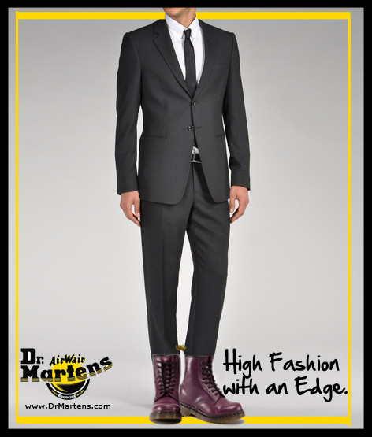

Outdoor Ad: “High Fashion with an Edge” - Billboard



